Assignment-3 Normalization

- What is Normalization? Explain 1NF, 2NF,3NF with suitable(same data) example.
- Explain Codd’s 12 Rules for a Relational Database Management System (RDBMS) and their significance in ensuring data integrity, consistency, and usability. Give examples wherever necessary.
- What is Anomalies? Define Insert, Update and Delete Anomalies with suitable example.
- Define transitive dependency. How does 3NF remove it?
- Explain Boyce-Codd Normal Form (BCNF) with an example.

- What is functional Dependency? Explain which type of FD is not allowed in 3NF and decompose the relation to convert it into 3NF.
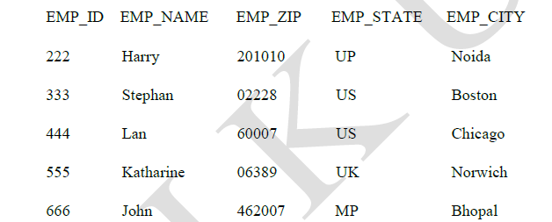

- Consider the following relation and its functional dependencies. Assume that the relation is in 1NF and convert the relation in 2NF and 3NF with the rules for each decomposition.
R = {Proj#, Proj_Name, Emp#, Emp_Name, Job_Class, Chg_Per_Hr, Hours}

FD1: {Proj#, Emp#} -> Hours
FD2: {Job_Class} -> {Chg_Per_Hr}

- Normalize the given relation: BRANCH (Branch#, Branch_Addr, ISBN, Title, Author, Publisher, Num_copies) and give explanation for decomposition of the relation to convert it into 2nd normal form.

Consider few functional dependancies like Branch# -> ISBN, ISBN -> Title, {Branch#, ISBN} -> Num_Copies
- Emp (SSN, Birth_Date, Department, Proj_Manager, Proj_Handled)
Here it is to be assumes that one employee will work for one department only but can handle multiple projects and for each project there with be a project manager(another employee from
same or different department).
- Convert the following relation into 3NF and then BCNF. Explain the difference between both normal forms.
R = {Property_ID, City, Plot_No, Area, Price}
Functional Dependencies are given as below:
FD1: Property_ID -> {City, Plot_No, Area, Price}
FD2: {City, Plot_No} -> {Property_ID, Area, Price}
FD3: Area -> Price
FD4: Area -> City

